NOTE: Exercises should never be painful. If they are, stop doing them and consult a physical therapist.
Trapezius Upper Fibers Stretch
Performing Arts Injury Prevention
Stretches for the Upper Back and Neck
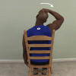
Directions: Grasp side of chair with [involved] hand, place [uninvolved] hand on head, pull head to the [uninvolved] side and hold 30 seconds, repeat 1-2 times.

Levator Scapula Stretch
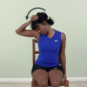

Directions: Sit or stand with good erect posture and hook fingers of [involved] hand under chair seat, bend neck forward and to [uninvolved] side looking under [uninvolved] arm, gently assist stretch with [uninvolved] hand on top of head, hold 30 seconds, repeat 1-2 times.

Side-bend Trunk Stretch – Sitting or Standing
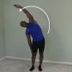
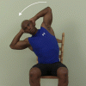
Directions: Sit in chair with good posture, and hands behind head, curl sideways taking [uninvolved] elbow towards ground. Or stand and reach overhead and curl sideways. hold 10 seconds, while taking a feH deep breaths, return to starting position and repeat 1-2 times.

Stretches for the Low Back and Hips
Trunk Extension Standing Overhead Reach Stretch
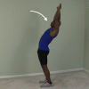
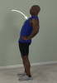
Directions: Arms on hips or overhead reach overhead as far as possible, hold 10 seconds, return to starting position, repeat 3 times. Perform throughout the day, especially to break up periods of sitting.

Hamstring Standing Foot Up Forward Lean Stretch
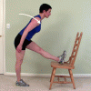
Directions: Place heel on seat of chair, maintain slight arch in low back and lean trunk forward bending at hips and hold 30 seconds, return to starting position, repeat 1-2 times.

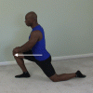
Hip Extension Lunge Stretch

Directions: Kneel on [involved] leg, bend [uninvolved] leg in front of you with foot flat on floor lunge forward keeping [involved] knee on floor and hold 30 seconds, repeat 1-2 times.

Lumbar Flexion Toe Touches
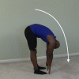
Directions: Curl trunk forward reaching hands toward floor, keep knees straight throughout the exercise, and hold 30 seconds, return to starting position, repeat 1-2 times.

Lumbar Flexion with Rotation Sitting Stretch Unilateral
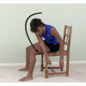
Directions: Sit on front edge of chair and knees together, curl trunk forward reaching to the [involved] of legs, hold 30 seconds, return to starting position, repeat 1-2 times.

Gluteus Medius, Minimus Standing Stretch
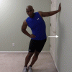

Directions: Stand with [involved] side next to wall, place [involved] arm on wall above shoulder level, lean hips toward wall keeping trunk erect and hold 30 seconds, repeat 1-2 times on each side.

Stretches for the Shoulder
Pectoralis Corner Stretch
Directions: Place forearms on walls in corner, create stretch by leaning towards the corner of the room, and hold 30 seconds, repeat 1-2 times. (This stretch can also be done in a doorway.)

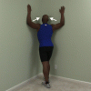

Internal Rotation Hand Assisted Behind Back Stretch
Internal Rotation Hand Assisted Behind Back Stretch Directions: Bring [involved] hand behind back, use [uninvolved] to press [involved] hand out away from belt line, hold 30 seconds, repeat 1-2 times.
.
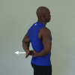

Shoulder Horizontal Adduction Stretch
Shoulder Horizontal Adduction Stretch Directions: Use [uninvolved] hand at [involved] elbow to pull arm across in front of you, hold 30 seconds, repeat 1-2 times.

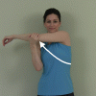

Triceps Stretch
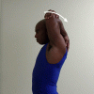
Triceps Stretch Directions: With [involved] hand fully overhead and elbow fully bent, press [involved] elbow back by pushing with [uninvolved] hand. Hold 30 seconds, repeat 1-2 times.

Standing Flexion Wall Climb Stretch
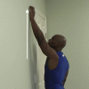

Standing Flexion Wall Climb Stretch Directions: Place [involved] fingers on the wall, "walk" your fingers up the wall until a stretch is felt in the shoulder, hold 5 seconds, slowly "walk" your fingers back down to starting position, do 3 times.

Stretches for the Wrist and Hand
Wrist Extension Prayer Stretch (for wrist and finger flexors)
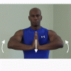
Directions: Place palms together, fingers up, directly in front of you, create stretch by bringing elbows up, hold stretch 30 seconds, repeat 1-2 times.

Extensor Muscle Stretch
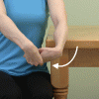
Directions: Grasp back of [involved] hand with [uninvolved] hand, keeping elbow straight throughout exercise, use [uninvolved] to bend [involved] wrist down and in and hold 30 seconds, repeat 1-2 times.

Pronation Hand Assisted Stretch
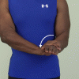
Directions: With [involved] elbow at side use [uninvolved] hand to grasp [involved] wrist and force into palm down position, hold 30 seconds, repeat 1-2 times.

Supination Stretch
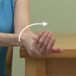

Finger Flexor Stretch
Directions: Use [uninvolved] hand to push [involved] hand into palm up position, hold 30 seconds, return to start position, repeat 1-2 times.
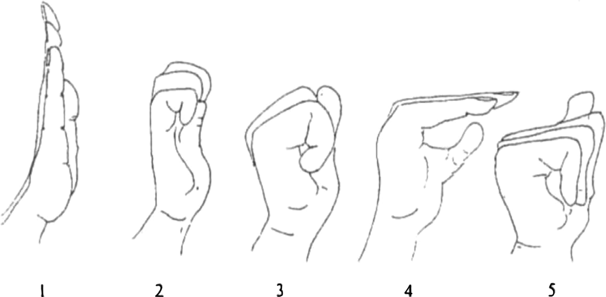
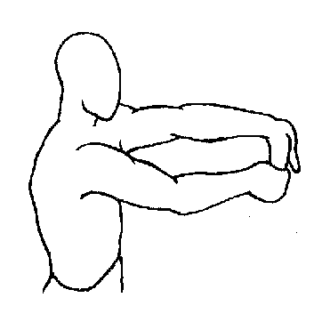
Directions: Grab your [involved] fingers with your [uninvolved] hand, bend [involved] fingers and wrist away, palm up, hold 30 seconds, repeat 1-2 times.

Tendon glide exercise (position B is a lumbrical muscle stretch, helpful for people who finger instruments)

Median nerve stretch
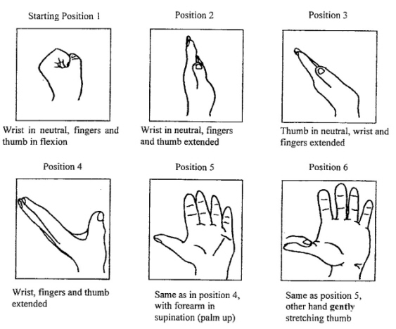
Nerve Glides
Median Nerve Glides: from gentle to more aggressive

Ulnar Glides: from gentle to more aggressive

Self test: If your 4th & 5th finger or elbow symptoms increase with the movement shown to the left, you may have a problem with your ulnar nerve

Radial Nerve Glides: from gentle to more aggressive
If your thumb symptoms increase with the movement shown left, your problem may be in the radial nerve.

