**NOTE: Exercises should never be painful. If they are, stop doing them and consult a physical therapist.**

**Trapezius Upper Fibers Stretch**

**Performing Arts Injury Prevention**

**Stretches for the Upper Back and Neck**

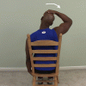

**Directions:** Grasp side of chair with [involved] hand, place [uninvolved] hand on head, pull head to the [uninvolved] side and hold 30 seconds, repeat 1-2 times.

**Levator Scapula Stretch**

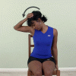

**Directions:** Sit or stand with good erect posture and hook fingers of [involved] hand under chair seat, bend neck forward and to [uninvolved] side looking under [uninvolved] arm, gently assist stretch with [uninvolved] hand on top of head, hold 30 seconds, repeat 1-2 times.

**Side-bend Trunk Stretch – Sitting or Standing**

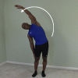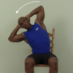

**Directions:** Sit in chair with good posture, and hands behind head, curl sideways taking [uninvolved] elbow towards ground. Or stand and reach overhead and curl sideways. hold 10 seconds, while taking a feH deep breaths, return to starting position and repeat 1-2 times.

**Stretches for the Low Back and Hips**

**Trunk Extension Standing Overhead Reach Stretch**

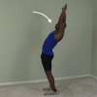

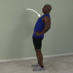

**Directions:** Arms on hips or overhead reach overhead as far as possible, hold 10 seconds, return to starting position, repeat 3 times. Perform throughout the day, especially to break up periods of sitting.

**Hamstring Standing Foot Up Forward Lean Stretch**

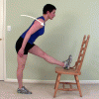

**Directions:** Place heel on seat of chair, maintain slight arch in low back and lean trunk forward bending at hips and hold 30 seconds, return to starting position, repeat 1-2 times.

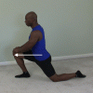 **Hip Extension Lunge Stretch**

**Directions:** Kneel on [involved] leg, bend [uninvolved] leg in front of you with foot flat on floor lunge forward keeping [involved] knee on floor and hold 30 seconds, repeat 1-2 times.

**Lumbar Flexion Toe Touches**

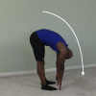

**Directions:** Curl trunk forward reaching hands toward floor, keep knees straight throughout the exercise, and hold 30 seconds, return to starting position, repeat 1-2 times.

**Lumbar Flexion with Rotation Sitting Stretch Unilateral**

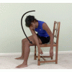

**Directions:** Sit on front edge of chair and knees together, curl trunk forward reaching to the [involved] of legs, hold 30 seconds, return to starting position, repeat 1-2 times.

**Gluteus Medius, Minimus Standing Stretch**

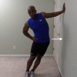

**Directions:** Stand with [involved] side next to wall, place [involved] arm on wall above shoulder level, lean hips toward wall keeping trunk erect and hold 30 seconds, repeat 1-2 times on each side.

**Stretches for the Shoulder**

**Pectoralis Corner Stretch**

**Directions:** Place forearms on walls in corner, create stretch by leaning towards the corner of the room, and hold 30 seconds, repeat 1-2 times. (This stretch can also be done in a doorway.)

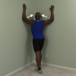

**Internal Rotation Hand Assisted Behind Back Stretch**

**Internal Rotation Hand Assisted Behind Back Stretch Directions:** Bring [involved] hand behind back, use [uninvolved] to press [involved] hand out away from belt line, hold 30 seconds, repeat 1-2 times.

.

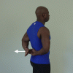

**Shoulder Horizontal Adduction Stretch**

**Shoulder Horizontal Adduction Stretch Directions:** Use [uninvolved] hand at [involved] elbow to pull arm across in front of you, hold 30 seconds, repeat 1-2 times.

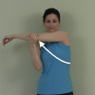

**Triceps Stretch**

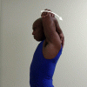

**Triceps Stretch Directions:** With [involved] hand fully overhead and elbow fully bent, press [involved] elbow back by pushing with [uninvolved] hand. Hold 30 seconds, repeat 1-2 times.

**Standing Flexion Wall Climb Stretch**

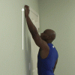

**Standing Flexion Wall Climb Stretch Directions:** Place [involved] fingers on the wall, "walk" your fingers up the wall until a stretch is felt in the shoulder, hold 5 seconds, slowly "walk" your fingers back down to starting position, do 3 times.

**Stretches for the Wrist and Hand**

**Wrist Extension Prayer Stretch (for wrist and finger flexors)**

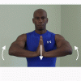

**Directions:** Place palms together, fingers up, directly in front of you, create stretch by bringing elbows up, hold stretch 30 seconds, repeat 1-2 times.

**Extensor Muscle Stretch**

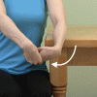

**Directions:** Grasp back of [involved] hand with [uninvolved] hand, keeping elbow straight throughout exercise, use [uninvolved] to bend [involved] wrist down and in and hold 30 seconds, repeat 1-2 times.

**Pronation Hand Assisted Stretch**

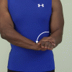

**Directions:** With [involved] elbow at side use [uninvolved] hand to grasp [involved] wrist and force into palm down position, hold 30 seconds, repeat 1-2 times.

**Supination Stretch**

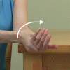

**Finger Flexor Stretch**

**Directions:** Use [uninvolved] hand to push [involved] hand into palm up position, hold 30 seconds, return to start position, repeat 1-2 times.

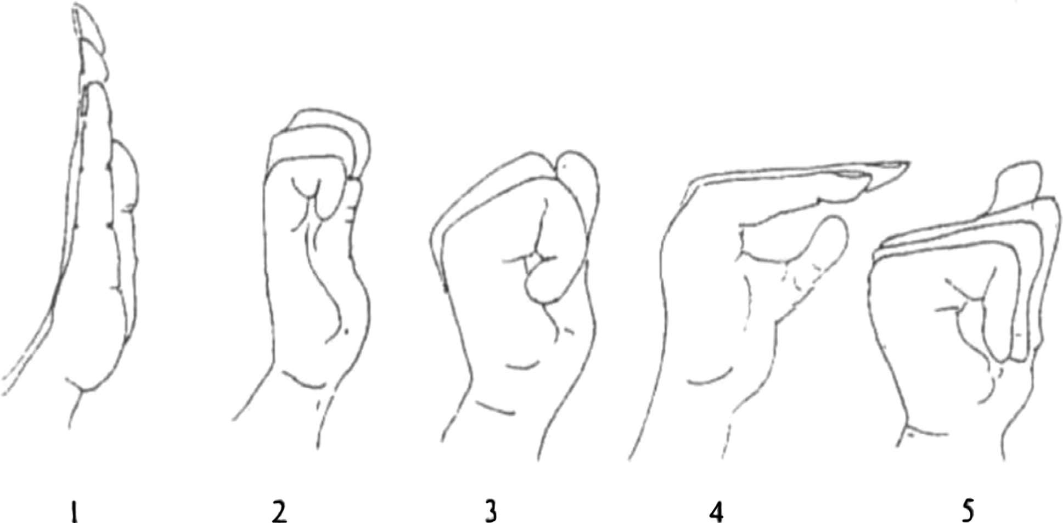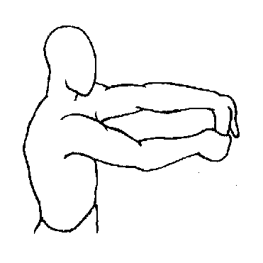

**Directions:** Grab your [involved] fingers with your [uninvolved] hand, bend [involved] fingers and wrist away, palm up, hold 30 seconds, repeat 1-2 times.

**Tendon glide exercise (position B is a lumbrical muscle stretch, helpful for people who finger instruments)**

**Median nerve stretch**

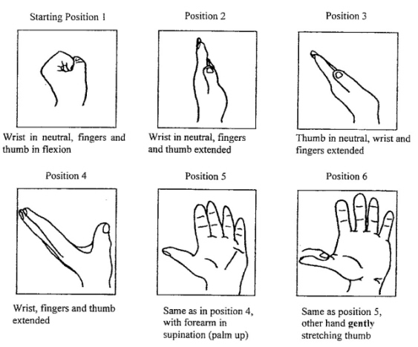

**Nerve Glides**

**Median Nerve Glides: from gentle to more aggressive**







**Ulnar Glides: from gentle to more aggressive**

**Self test: If your 4th & 5th finger or elbow symptoms increase with the movement shown to the left, you may have a problem with your ulnar nerve**





**Radial Nerve Glides: from gentle to more aggressive**



**If your thumb symptoms increase with the movement shown left, your problem may be in the radial nerve.**



